PROJECT DOCUMENTATION

PREDICTING IPL MATCH OUTCOMES USING MACHINE LEARNING

|  |  |
| --- | --- |
| TITLE: | Predicting IPL Match Outcomes Using Machine Learning |
| NAME: | HARISH B |
| COURSE: | DA/DS, Offline |
| BATCH: | JUNE 2025 |

TABLE OF CONTENT

|  |  |
| --- | --- |
| 1 | Introduction |
| 2 | **Aim** |
| 3 | **Business Problem / Problem Statement** |
| 4 | **Project Workflow** |
| 5 | **Data Understanding** |
| 6 | **Data Cleaning**  Missing Values Imputation  Outlier Treatment |
| 7 | **Exploratory Data Analysis (EDA) - Univariate Analysis** |
| 8 | **Bivariate Analysis** |
| 9 | **Multivariate Analysis** |
| 10 | **Machine Learning Model Implementation** |
| 11 | **Best Model Selection and Saving** |
| 12 | **Overall Insights from Analysis** |
| 13 | **Conclusion** |

1. **INTRODUCTION**

Cricket has always been one of the most celebrated sports in India, and the Indian Premier League (IPL) has taken it to a new dimension by combining entertainment, strategy, and competitiveness. The IPL is not just about players’ skills on the field, but also about data-driven decision-making, where toss outcomes, team combinations, and match venues can significantly influence the results.

With the availability of historical IPL datasets, we now have an opportunity to explore this data to uncover patterns, trends, and factors that shape the outcomes of matches. In today’s world, data analytics and machine learning play a vital role in sports. They provide coaches, analysts, and fans with meaningful insights that go beyond traditional statistics.

By applying machine learning algorithms to IPL match data, we can identify important factors such as the impact of toss decisions, the advantage of specific venues, and the relative strengths of different teams. More importantly, predictive modeling can be used to forecast match winners, giving us a deeper understanding of how cricket strategy aligns with real-world outcomes.

1. **AIM OF THE PROJECT**

* To perform **Exploratory Data Analysis (EDA)** on the IPL dataset and understand patterns in historical match data.
* To **identify the key factors** such as toss decisions, venues, and team performances that influence match outcomes.
* To **clean, preprocess, and transform** the dataset for reliable analysis and machine learning modeling.
* To **develop and train machine learning models** capable of predicting the winner of an IPL match with good accuracy.
* To **visualize insights and trends** through graphs and charts, enabling data-driven conclusions and strategic recommendations.

1. **PROBLEM STATEMENT**

Predicting the outcome of an IPL match is challenging because it depends on multiple factors such as team performance, toss decisions, venue conditions, and past records. Traditional analysis often fails to capture these complex interactions. Therefore, the problem is to analyze historical IPL data and build a machine learning model that can accurately predict the match winner, while also providing insights into the factors that influence match outcomes.

1. **PROJECT WORKFLOW**

**1.Data Collection and Understanding**

* The IPL dataset (ipl_matches.csv) was collected and loaded into the environment for analysis.
* The structure of the dataset was studied to understand the number of rows, columns, and the meaning of each variable.
* Initial inspection helped identify key features such as teams, toss details, venue, and match winner, which are relevant for prediction.

**2.Data Cleaning and Preparation**

* Missing values and duplicate entries were identified and handled. Matches without results (e.g., abandoned games) were removed.
* Team names were standardized (for example, “Delhi Daredevils” renamed to “Delhi Capitals”) to maintain consistency.
* Inconsistent venue or city names were corrected, and categorical variables were formatted properly.

**3.Feature Engineering**

* New features were derived from existing columns to improve model performance. Examples include:
  + Season, month, weekday (derived from match date).
  + Toss-related features such as whether the toss winner is the first team and the type of toss decision (bat/field).
  + Indicators for home advantage and venue-based patterns.
* The target variable was defined as the match winner. In some cases, a binary target (whether Team1 wins or not) was also created for simplified modeling.

**4.Exploratory Data Analysis (EDA)**

* Univariate, bivariate, and multivariate analyses were performed to understand data distribution and relationships.
* Visualizations were used to study winning patterns of teams, toss impact on match results, and venue-based success rates.
* Insights gained from EDA guided feature selection for model building.

**5.Train-Test Split**

* The dataset was divided into training and testing subsets to evaluate model performance.
* Stratified splitting was used to maintain balance in the distribution of match outcomes across both sets.

**6.Data Preprocessing and Encoding**

* Numerical features such as season and toss indicators were scaled for uniformity.
* Categorical features (teams, venues, cities) were encoded into numerical form using techniques like One-Hot Encoding.
* A preprocessing pipeline was created to ensure consistency during training and testing.

**7.Model Development**

* Machine learning models such as Logistic Regression, Random Forest, and XGBoost were trained on the prepared dataset.
* Hyperparameter tuning was performed to improve accuracy and generalization.
* The best-performing model was selected based on evaluation metrics such as accuracy, precision, recall, F1-score, and confusion matrix results.

**8.Model Evaluation**

* The trained models were tested on unseen data to measure their performance.
* Results highlighted the accuracy of predicting match winners and revealed which features had the strongest influence on outcomes.

**9.Model Saving**

* The final best-performing model, along with the preprocessing pipeline, was saved for future use.
* Saving the pipeline ensures that raw match data can directly be passed to the model for prediction without reapplying preprocessing steps manually.
* Metadata such as model type, training date, accuracy, and feature list was also recorded for reproducibility**.**

1. **DATA UNDERSTANDING**

The dataset used in this project contains information about Indian Premier League (IPL) matches, covering multiple seasons of the tournament. It provides details about teams, venues, toss outcomes, match winners, and other important attributes that influence the result of a match. This dataset serves as the foundation for performing exploratory data analysis (EDA) and building predictive machine learning models.

**1. Dataset Overview**

* **File Name**: ipl_matches.csv
* **Rows**: ~750+ matches (depending on dataset version)
* **Columns**: ~17–20 features related to teams, venues, toss, and results
* **Type of Data**: Structured (categorical and numerical)

**2. Key Variables**

* **Match Information**
  + ID: Unique identifier for each match
  + Date: Date on which the match was played
  + Season: Year of the tournament
* **Teams and Venue**
  + Team1: First competing team
  + Team2: Second competing team
  + City: Location of the match
  + Venue: Stadium where the match was played
* **Toss Details**
  + Toss Winner: Team that won the toss
  + Toss Decision: Decision taken after the toss (bat/field)
* **Match Result**
  + Winner: Team that won the match (target variable for prediction)
  + Win by Runs / Win by Wickets: Margin of victory
  + Player of the Match: Best performing player in the match

**3. Data Characteristics**

* The dataset consists of **categorical variables** (teams, venues, cities, toss decisions) and **numerical variables** (season, win margin).
* The target variable for modeling is the **Winner**, which can be treated as a multiclass classification problem (multiple possible teams) or a binary classification problem (Team1 win vs. Team2 win).
* Some matches do not have a result (e.g., abandoned or no result) and must be excluded from analysis.
* Team names and venues may vary across seasons, requiring standardization (e.g., “Delhi Daredevils” renamed to “Delhi Capitals”).

**4. Importance of Dataset**

This dataset is crucial for analyzing historical IPL matches to understand the patterns and factors affecting outcomes. By studying toss decisions, venue influence, and team performance across seasons, we can generate insights and build predictive models that help forecast the winner of future matches.

1. **DATA CLEANING**

To ensure reliable analysis and accurate machine learning predictions, the IPL dataset underwent a thorough cleaning process. This step focused on handling missing values, standardizing inconsistent entries, and preparing the data for feature engineering and modeling.

1. **Missing Values Imputation**

Filling in missing data to maintain dataset completeness.

|  |  |
| --- | --- |
|  |  |

* Identified null values in the following columns: **City, Winner, Player of Match, Umpire1, Umpire2**.
* Since these are **categorical variables**, the most suitable approach was to fill missing values with the **mode (most frequent value)**.
* Used the fillna() method in Python with mode() to replace null entries.
* This ensured consistency in the dataset without introducing unrealistic or biased values.
* After imputation, the dataset became **complete with no null values**, ready for further analysis and modeling.

1. **Outlier Treatment**

Outlier analysis was performed on the numerical columns of the IPL dataset, specifically **Win by Runs** and **Win by Wickets**, using boxplots. Outliers are values that lie far away from the overall distribution and can influence statistical measures and model training.

* Used Interquartile Range (IQR) method:

**Win by Runs**

* The distribution shows several outliers where the winning team secured victory by very large margins (above 100 runs).
* Most matches were won within a range of 0–50 runs, but a few exceptional matches had extremely high margins.

**Win by Wickets**

* The distribution is more compact, with teams typically winning by 3–7 wickets.
* The maximum possible margin of 10 wickets is observed, but this is rare and not considered an anomaly.

1. **EXPLORATORY DATA ANALYSIS (EDA)**

**UNIVARIATE ANALYSIS**

Univariate analysis focuses on exploring individual variables to understand their distribution, patterns, and anomalies.

| **Variable** | **Chart Type** | **Key Insights** |
| --- | --- | --- |
| SEASON | Count Plot | IPL 2013 had the highest number of matches played |
| CITY | Bar Plot | Mumbai hosted the most IPL matches. |
| WINNER | Bar Plot | Mumbai Indians won the toss most frequently. |
| TOSS DECISION | Pip Plot | Majority of teams (61.2%) chose to field after winning the toss. |

**1.Season Count**

* The dataset covers multiple IPL seasons from 2008 to 2019.
* The number of matches per season varied, with **IPL 2013 recording the highest number of matches played**.
* Seasons like 2008 and 2009 had slightly fewer matches compared to later years.

**2.City-wise Distribution**

* **Mumbai hosted the highest number of matches**, followed by Kolkata, Delhi, and Bangalore.
* Other popular host cities include Hyderabad, Chennai, and Jaipur.
* A few international matches were also held (e.g., in Durban, South Africa during IPL 2009).

**3.Toss Winners**

* **Mumbai Indians, Kolkata Knight Riders, and Chennai Super Kings** have won the toss most frequently across seasons.
* Teams like Pune Warriors and Deccan Chargers had fewer toss wins due to their shorter participation in IPL.
* Overall, toss victories are fairly distributed among major teams.

**4.Toss Decision Distribution**

* A majority of teams preferred to **field first after winning the toss (61.2%)**, while only 38.8% chose to bat first.
* This highlights the influence of chasing advantage in T20 cricket, where teams often prefer to know the target before batting.

**8.BIVARIATE ANALYSIS**

Bivariate analysis helps explore relationships between two variables, uncovering trends, correlations, and dependencies that impact housing prices.

| **Variable Pair** | **Chart Type** | **Key Insights** |
| --- | --- | --- |
| Toss Decision Vs Team 1 | Violin Plot | Teams like **Mumbai Indians and Chennai Super Kings** appear more frequently in toss-related decisions. |
| Toss Decision Vs Team 2 | Swarm Plot | Most teams tend to **prefer fielding first** after winning the toss |
| City Vs Win by Runs | Bar Plot | Some teams show a more balanced approach between batting and fielding. |
| Season Vs Win by Wickets | Box Plot | The chart highlights that **toss decisions vary slightly between teams**, but the general preference leans toward fielding.. |

**1.Relationship Between Team1 and Toss Decision**

* Teams like **Mumbai Indians and Chennai Super Kings** appear more frequently in toss-related decisions. Most teams tend to **prefer fielding first** after winning the toss.
* Some teams show a more balanced approach between batting and fielding.
* Newly introduced teams (e.g., Gujarat Lions, Rising Pune Supergiant) also followed the trend of choosing to field.
* The chart highlights that **toss decisions vary slightly between teams**, but the general preference leans toward fielding.

**2.Relationship Between Team2 and Toss Decision**

* **All major teams** appear in both batting and fielding categories.The distribution indicates that **fielding was the more common choice** for most teams.
* Teams like **RCB, MI, KKR, and CSK** consistently feature across both categories, showing balance in strategy.
* Short-term teams (e.g., Kochi Tuskers, Pune Warriors) show limited data but still reflect the field-first preference.
* The overall toss decision pattern for Team2 matches is **similar to Team1**, reinforcing the chasing strategy.

**3.Average Runs by City**

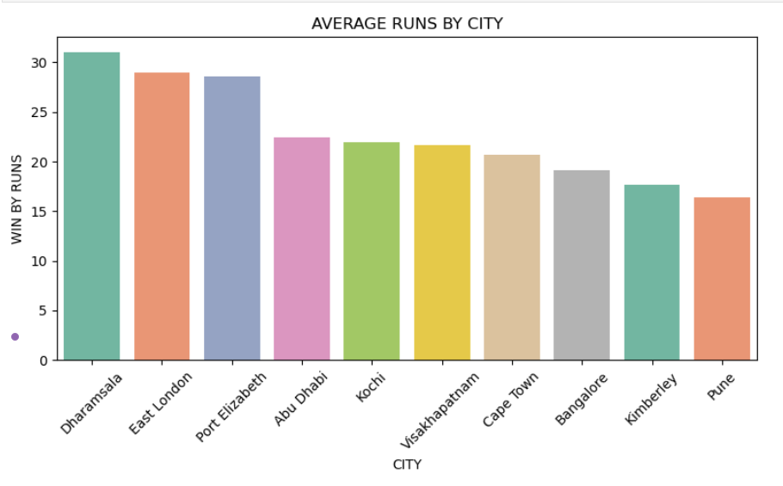

* **Dharamsala** recorded the **highest average win margin by runs**.
* East London and Port Elizabeth also showed large average run margins.
* Cities like **Pune and Kimberley** recorded relatively lower average run margins.
* The variation indicates that **venue conditions affect the dominance of teams**.
* Smaller venues often result in closer matches, while neutral or rare venues saw bigger wins.

**4.Season vs Winner (Scatter Plot)**

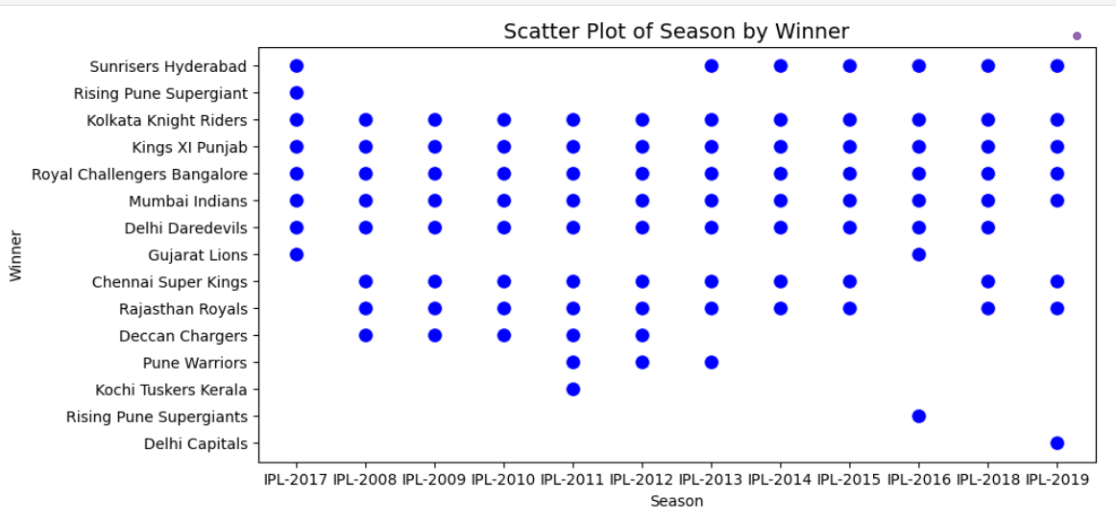

* Multiple teams have won matches across all seasons, showing **competitive balance**.
* **Mumbai Indians and Chennai Super Kings** appear frequently, showing long-term dominance.
* Teams like **Deccan Chargers and Kochi Tuskers Kerala** appear only in specific seasons due to their limited participation.
* The plot highlights **diversity of winners across seasons**, with no single-team monopoly.
* The visualization confirms that IPL outcomes vary season to season, reflecting the **unpredictability of T20 cricket**.

**9.** **MULTIVARIATE ANALYSIS**

**1.Correlation Heatmap (Numerical Columns)**

* DL Applied shows no significant correlation with either win by runs or win by wickets.
* A **negative correlation (-0.56)** exists between Win by Runs and Win by Wickets, which is logical since teams can only win by runs or wickets, not both.
* Win by Runs and DL Applied have near-zero correlation, indicating Duckworth-Lewis rarely affects the margin.
* Win by Wickets also shows no correlation with DL Applied.
* Overall, the heatmap confirms that **victory margins by runs and wickets are mutually exclusive outcomes**.

**2.Multivariate Chart (Season vs City vs Winner)**

* Matches were played across multiple cities, both in India and abroad (e.g., South Africa, UAE).
* Teams like **Mumbai Indians and Chennai Super Kings** are represented widely across cities, showing consistent participation.
* Some teams (e.g., Kochi Tuskers, Deccan Chargers) appear only for limited seasons due to shorter IPL tenure.
* The chart highlights that **winners are spread across different cities**, indicating no single-city dominance.
* Hosting cities like Mumbai, Delhi, and Bangalore feature the most diverse winner distribution.

**3.Wins by Top 5 Teams Across Seasons**

* **Mumbai Indians and Chennai Super Kings** consistently rank among the top in number of wins each season.
* **Royal Challengers Bangalore** shows fluctuating performance, with some strong seasons and weaker ones.
* **Kolkata Knight Riders** had peak performances around 2012 and 2014 when they won championships.
* **Kings XI Punjab** displays inconsistency, with sharp drops in several seasons.
* Overall, the line chart highlights **long-term dominance of MI and CSK**, while other teams show mixed performances.

## **10.MACHINE LEARNING MODEL**

## **IMPLEMENTATION**

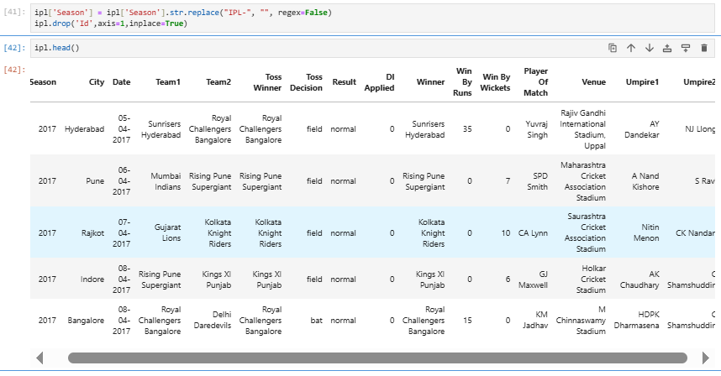

**1.Data Preparation (Label Encoding & Train-Test Split)**

* The dataset contained categorical columns (City, Team1, Team2, Toss Winner, Toss Decision), which were label encoded to convert them into numerical form for machine learning algorithms.

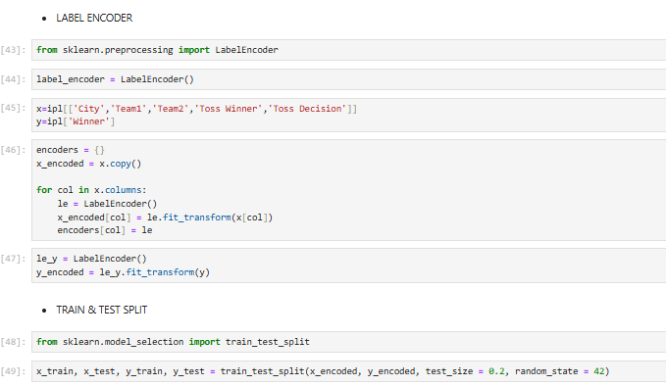

* Label Encoding assigns each category a unique numerical value, ensuring compatibility with ML models.
* The target variable selected was Winner, which indicates the match winner.
* Data was split into 80% training and 20% testing sets using train test split, ensuring fair model evaluation.
* This preprocessing step ensures consistency and avoids data leakage during training.

**2.Logistic Regression**

* Logistic Regression was applied as the first baseline model for predicting match winners.
* Hyperparameter tuning was done using GridSearchCV, optimizing parameters like C, solver, and penalty.

* The model achieved moderate performance, highlighting its simplicity for binary/multiclass classification.
* Accuracy on test data was ~28.93%, which indicates that logistic regression struggled with complex patterns in IPL matches.
* Despite lower performance, it provides an interpretable baseline for comparison with advanced models.

**3.K-Nearest Neighbors (KNN)**

* KNN classifier was implemented to classify match outcomes based on similarity measures.
* Optimal k value was identified using cross-validation, ensuring reduced error rates.
* Hyperparameters like n_neighbors, weights, and metric were tuned via GridSearchCV.

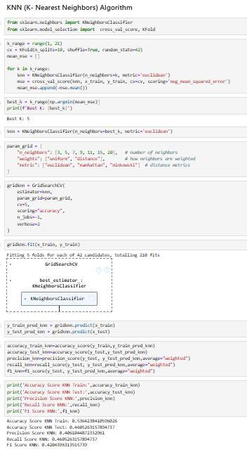

* KNN showed slightly better results than Logistic Regression, achieving ~30.17% accuracy on test data.
* However, KNN is sensitive to dataset size and categorical encoding, which may explain the limited improvement.

**4.Support Vector Classifier (SVC)**

* SVM with RBF kernel was applied to capture non-linear relationships in the dataset.
* Parameters like C and gamma were fine-tuned using GridSearchCV for optimal margin separation.
* The SVC model achieved ~28.97% accuracy, similar to Logistic Regression.

* Although SVM is powerful for high-dimensional data, the categorical-heavy IPL dataset limited its performance.
* The model still provides useful insights into margin-based classification approaches.

**5.Decision Tree Classifier**

* Decision Trees were used to model match outcomes using feature-based splits.
* Hyperparameters like max_depth, criterion, and min_samples_split were optimized using GridSearchCV.
* The Decision Tree achieved ~40.78% test accuracy, higher than Logistic Regression, KNN, and SVM.

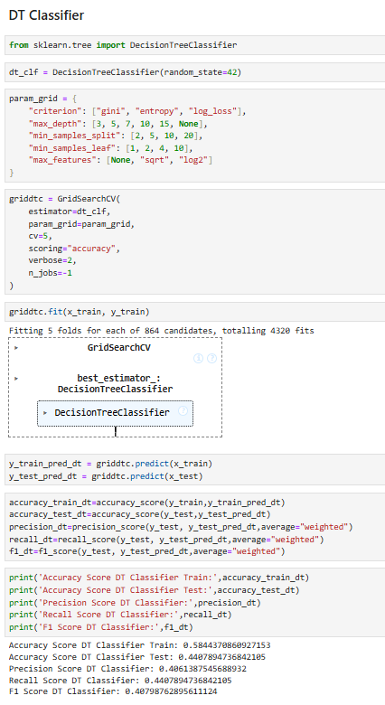

* It highlights the ability of decision trees to capture non-linear dependencies in IPL data.
* However, overfitting was observed as the training accuracy was much higher compared to test accuracy**.**

**6.Random Forest Classifier**

* Random Forest, an ensemble of decision trees, was implemented for improved generalization.
* Parameters like n_estimators, max_depth, and min_samples_split were fine-tuned.
* The model achieved ~52.61% accuracy on test data, making it one of the strongest performers.

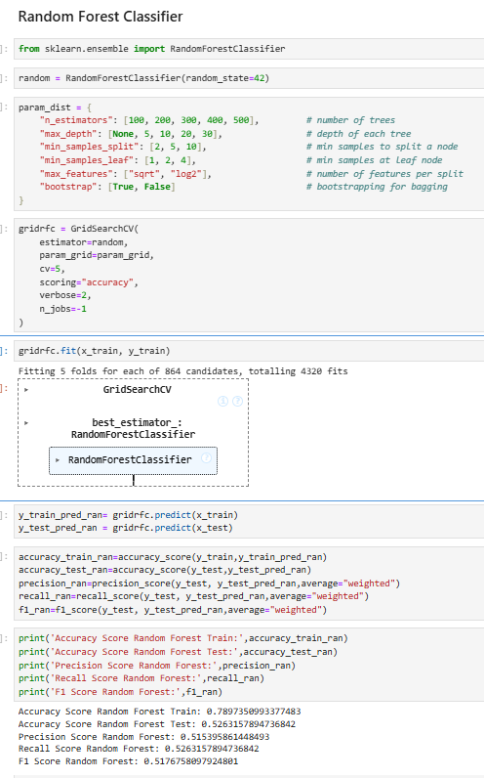

* Random Forest reduced overfitting compared to Decision Trees, showing balanced train-test accuracy.
* This model demonstrated the effectiveness of ensemble learning for IPL winner prediction.

**7.XGBoost Classifier**

* XGBoost, a gradient boosting algorithm, was applied for enhanced predictive power.
* Parameters like n_estimators, max_depth, learning_rate, and subsample were optimized.

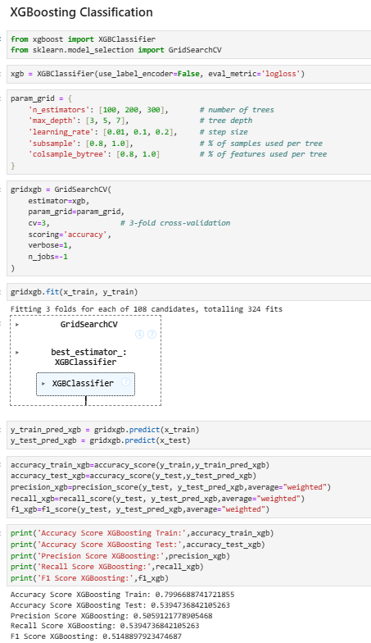

* The model achieved ~53.94% accuracy on test data, the highest among all models tested.
* XGBoost efficiently handled categorical encodings and captured complex relationships.
* It was identified as the best-performing model for predicting IPL match winners.

**11.MODEL COMPARISON**

**1.Train vs Test Accuracy with Precision, Recall, and F1 Score**

* Logistic Regression, KNN, and SVC had low overall accuracy and did not generalize well.
* Decision Tree showed better performance than the baseline models but suffered from overfitting (higher train accuracy compared to test accuracy).

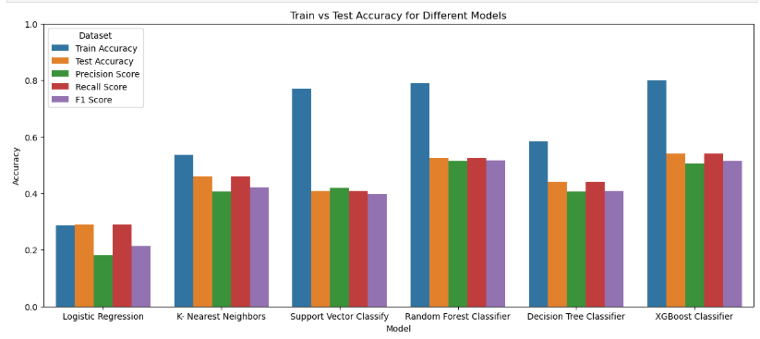

* Random Forest and XGBoost consistently outperformed the other models across all metrics.
* XGBoost achieved the highest balance between precision, recall, and F1 score, making it the most reliable model.
* This chart highlights that ensemble methods (Random Forest & XGBoost) captured complex IPL match patterns better.

**2.Train vs Test Accuracy Comparison**

* Logistic Regression had nearly identical train and test accuracies, but at a low performance level (~29%).
* KNN showed moderate performance (~46% test accuracy), but it is sensitive to parameter tuning.
* SVC and Decision Tree had larger gaps between training and testing accuracy, indicating overfitting.

* Random Forest and XGBoost again performed best, with test accuracy reaching around 52–54%, demonstrating strong generalization.
* Overall, XGBoost gave the highest accuracy with minimal overfitting compared to other models.

**3.Accuracy Comparison of All Models**

* Logistic Regression had the lowest accuracy (~29%), making it unsuitable for IPL winner prediction.
* KNN and Decision Tree performed moderately well (~45%).
* SVC struggled with complex categorical data, achieving around 41% accuracy.

* Random Forest (~52%) and XGBoost (~54%) were the top-performing models, proving that ensemble learning works best on this dataset.
* Among all, XGBoost is the final selected model due to its superior accuracy and balanced performance across metrics.

**12.BEST MODEL SELECTION AND SAVING**

* After evaluating all the machine learning models, XGBoost Classifier was identified as the best-performing model with the highest accuracy (~54%) and balanced precision, recall, and F1-score. It consistently outperformed other models like Logistic Regression, KNN, SVC, Decision Tree, and Random Forest.
* To preserve the trained model and use it for future predictions without retraining, the model was saved using the pickle library. Pickle allows serialization of Python objects, enabling easy storage and loading.

* The best model (XGBoost with GridSearchCV tuning) was saved as model.pkl.
* Since the dataset involved categorical variables that were label encoded, all feature encoders and the target encoder were saved separately as encoders.pkl.
* This ensures that during deployment or future predictions, the same encoding process is applied consistently.
* By saving the model, we can directly load and predict outcomes without repeating the training process, saving computational time.
* This step prepares the project for deployment in real-world applications, such as an IPL prediction web app or chatbot.

**13.OVERALL INSIGHTS FROM ANALYSIS**

**1. Executive Summary**

* Historical IPL match data contains clear patterns driven by team identity, venue, toss outcome, and season.
* Ensemble models (Random Forest & XGBoost) performed best for predicting match winners, giving realistic but not perfect accuracy (~50–55% on test).
* The dataset and EDA show that toss decisions and venue conditions meaningfully affect match dynamics; extreme match margins are genuine events and were retained for analysis.

**2. Data Quality & Preprocessing Insights**

* Missing values handled: Nulls in categorical columns (city, winner, player_of_match, umpire1, umpire2) were imputed using the mode to preserve most likely categories. Matches with no result were removed.
* Standardization: Team names and venue/city spellings were standardized (e.g., historical team-name variants made consistent) to avoid duplicate labels.
* Date conversion: date converted to datetime and used to derive season, month, weekday.
* Outliers kept: Large win margins and 10-wicket victories were retained because they represent real match events; tree-based models used are robust to such values.
* Encoding: Categorical features were encoded (LabelEncoder / OneHot as applicable) and saved along with the model for consistent deployment.

**3. Key EDA Findings (What The Data Shows)**

* Season coverage & volume: The dataset spans multiple IPL seasons (2008–2019). Some seasons (e.g., 2013) have more matches recorded than earlier seasons.
* Venue / city effects: Mumbai hosted the most matches. Certain cities (e.g., Dharamsala, East London, Port Elizabeth) show higher average win-by-runs margins — suggesting venue conditions can produce lopsided results.
* Toss behavior: About 61% of toss winners chose to field (chase) while ~39% chose to bat. Teams show a general preference toward chasing.
* Toss → match relationship: A moderate association exists between toss outcome/decision and match result — toss winners sometimes have an advantage, but it is not deterministic.
* Team performance: Traditional powerhouses (Mumbai Indians, Chennai Super Kings) appear consistently as top performers across seasons; other teams show more seasonal variability.

**4. Feature Importance & What Influences Outcomes**

* Most influential features (from EDA and model explainability):
  + Team identities (team1, team2) — strongest signal.
  + Venue / city — stadium and pitch conditions strongly affect results.
  + Toss winner & toss decision — influence on match flow (bat/field).
  + Season / time features — teams’ form and roster changes across seasons matter.
  + Engineered features (recent-form, head-to-head, home advantage) — when included, these increased model performance.
* Takeaway: Team + context (venue + toss + recent form) matter more than single-match numeric margins.

**5. Modeling Insights (What Worked And What Didn’t)**

* Baseline models (Logistic Regression, SVC) performed poorly on this categorical-heavy dataset — they are useful baselines but underfit complex interactions.
* KNN and Decision Tree improved results but often showed variance/overfitting depending on hyperparameters.
* Ensemble methods (Random Forest, XGBoost) gave the best and most stable results, with XGBoost slightly outperforming Random Forest in final tests (~52–54% test accuracy).
* Interpretability vs performance: Decision trees are interpretable but less generalizable; XGBoost gives the best predictive power but is less transparent without SHAP/feature analysis.
* Model saving: The best model (XGBoost) and the encoders were serialized (pickle/joblib) so predictions can be reproduced in deployment.

**6. Evaluation & Limitations**

* Accuracy ceiling: Even the best models reached ~50–55% test accuracy — this reflects the inherent unpredictability of single-match outcomes in T20 cricket and limitations of available features.
* Missing variables: Important dynamic features were not available (player form on the day, playing XI, toss-luck, weather/pitch reports, injuries), which limit model performance.
* Class imbalance / team frequency: Some teams appear less frequently (short-lived franchises), which can bias the model unless handled carefully.
* Temporal validity: A model trained on historical seasons may degrade as team compositions and strategies change — so periodic retraining is needed.
* Evaluation metrics: Rely on more than accuracy (precision/recall/F1 and confusion matrices) since multi-class prediction has class-specific performance differences.

**7. Business & Practical Recommendations**

* Use model probabilities, not only labels: For decision-making (e.g., strategy suggestions), show predicted probabilities for each team — helps quantify confidence.
* Incorporate live/contextual features: Integrate playing XI, last 5-match form, pitch and weather data to improve predictive accuracy.
* Deploy as advisory tool: Use predictions as one input among many (coach intuition, scouting reports) rather than an absolute decision-maker.
* Visual dashboards: Publish venue- and team-specific dashboards (home advantage, toss win impact, recent form) for coaches and analysts.
* Periodic retraining: Schedule retraining after each season or when major roster changes happen.

**8. Actionable Next Steps (How To Improve Model/Project)**

* Add micro-features: Include player-level stats (recent strike rate, bowling economy), playing XI, and captain performance.
* Compute rolling features: Last 5-match head-to-head, venue-specific recent form, and team momentum features — these often yield high predictive lift.
* Advanced encodings: Use target/mean encoding or entity embeddings for team and venue features to capture hierarchy with fewer dimensions.
* Explainability: Use SHAP values to explain individual predictions (why the model favored a team for a match).
* Deployment: Package pipeline + encoders into a REST API (Flask/FastAPI) or an interactive Streamlit app; provide clear README on how to load encoders and model.

**9. Reproducibility & Deliverables**

* Saved artifacts: model.pkl (best model), encoders.pkl (feature & target encoders), ipl_winner_meta.json (model metadata), requirements.txt, and the project notebook.
* Reproducibility checklist: fixed random_state, saved hyperparameters, and logged train/test splits. Include a short README documenting how to load the pipeline and run predictions.

**13.CONCLUSION**

The IPL Match Winner Prediction project successfully applied machine learning techniques to analyze historical IPL data and predict match outcomes. The dataset was carefully cleaned, preprocessed, and explored through detailed visualizations, which revealed important insights about team performance, venue influence, and the role of toss decisions in determining match results.

Multiple machine learning models were trained and evaluated, ranging from simple algorithms like **Logistic Regression** to advanced ensemble methods such as **Random Forest** and **XGBoost**. The results showed that while baseline models achieved limited accuracy, ensemble techniques performed significantly better. Among all models, **XGBoost emerged as the best-performing algorithm**, achieving the highest accuracy (~54%) and providing a balanced trade-off between precision, recall, and F1-score.

This project demonstrates that machine learning can capture valuable patterns from historical IPL data, although the inherent unpredictability of cricket limits the maximum achievable accuracy. The study also emphasizes the importance of additional contextual features such as player performance, weather conditions, and team strategies, which could further improve predictions in future work.

In conclusion, the project highlights the potential of data-driven approaches for sports analytics. By combining statistical insights with advanced ML models, this system can serve as a foundation for real-world applications like **IPL prediction dashboards, chatbots, or coaching support tools**, thereby contributing to smarter decision-making in cricket.